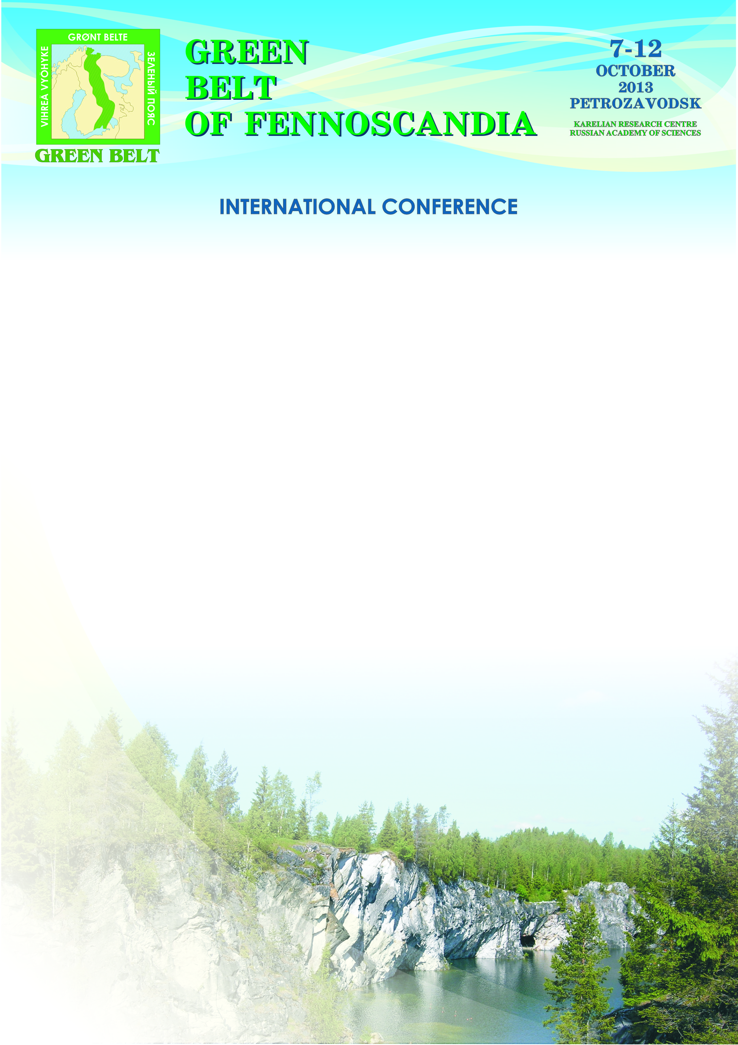
Dear colleagues,

Pre-registration for the conference “Green Belt of Fennoscandia”, Petrozavodsk, October 7-12, 2013 is closed. The Organizing Committee would like to thank you for your interest and willingness to participate as speakers and listeners.

You can learn about your participation format, specific dates and the session your talk will be in from the preliminary programme on the website
http://green-belt.krc.karelia.ru/event.php?id=191&plang=r .

Please note that the programme and other materials on the website will be regularly updated, and both the time and the format of presentation are subject to change.

CONFERENCE ITINERARY

October 7th, Monday
– arrivals, registration
October 8th, Tuesday
– registration
– plenary session
– session “natural complexes of GBF”
– ice-breaking party for conference participants
October 9th, Wednesday
– session “Historical and cultural heritage of GBF”
– session “Sustainable forest use, regeneration, and conservation”
October 10th, Thursday
– excursions around Petrozavodsk, museums in the city and in Karelian Research Centre
– roundtable “Russian-Finnish cross-border cooperation. ENPI projects – first results”
– session “North European PAs: Organization and Management Challenges”
October 11th, Friday
– session “…”, general discussion, summing up, resolution

Conference registration is open on October 7th from 9 a.m. to 6 p.m., and on October 8th from 9 a.m. to 10:30 a.m. in Room 221 of the Karelian Research Centre, 11 Pushkinskaya St., Petrozavodsk.
Participants are expected to make their own hotel reservations. You can find the list of hotels recommended by the Organizing Committee on the conference website. The map of Petrozavodsk in the attachment shows the locations of the hotels.

Please let us know ASAP if you have comments on the conference programme or detected a mistake. We also request you to inform the Organizing Committee if you won’t be able to attend the conference.

For questions concerning the conference please feel free to contact KarRC international relations officers Nadezhda Mikhailova and Igor Shevchuk (tel. 8-8142-780109, е-mail: greenbelt@krc.karelia.ru).

Organizing committee address:

Karelian Research Centre of RAS
11 Pushkinskaya St., 185910 Petrozavodsk
E-mail: greenbelt@krc.karelia.ru
Tel. 8-8142-780109

Visit http://green-belt.krc.karelia.ru for detailed and updated information about the conference.

Dear colleagues, you are cordially welcome to the conference!

CONFERENCE ORGANIZING COMMITTEE

