Tatarstan Academy of Sciences
Institute for Problems of Ecology and Mineral Wealth Use of TAS

Ministry of Science and Higher Education of the Russian Federation
RAS Earth Sciences Division
Northern Water Problems Institute of the Karelian Research Centre RAS

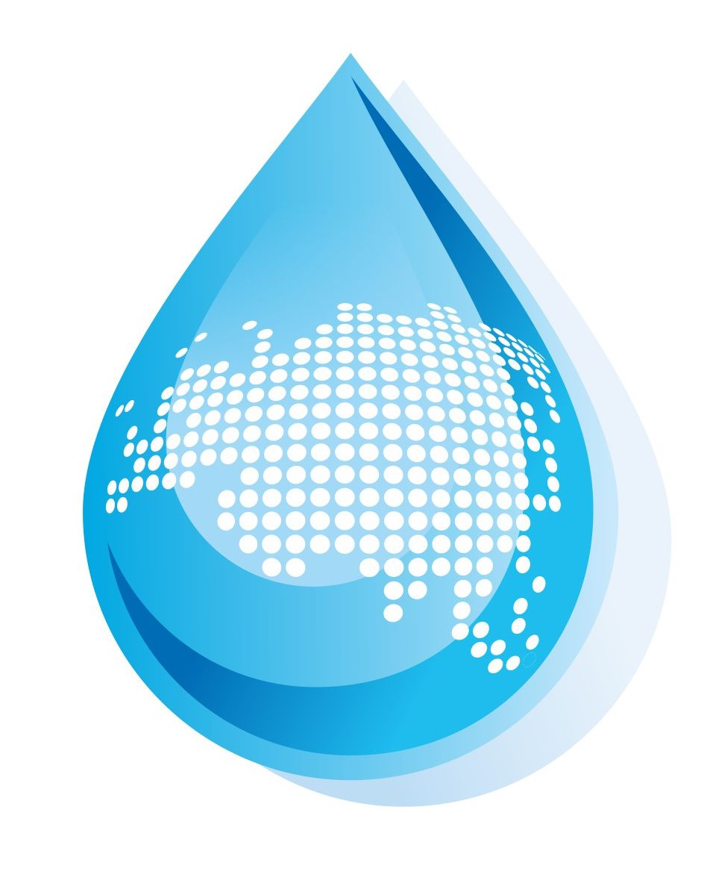
IIIrd International Conference

“Lakes of Eurasia: Problems and Solutions”
Kazan, May 20-23, 2025

First Circular
Dear colleagues,

you are invited to take part in the IIIrd International Conference

“Lakes of Eurasia: Problems and Solutions”

CONFERENCE THEMES
- Transboundary lake-river system. Challenges and solutions for shared use
- Current issues in lake conservation and use
- Alien species and their role in modifying lake ecosystems
- Dealing with the challenges of predicting intrasecular changes in hydrological regimes and ecosystems
- Emerging methods in ecosystem modeling to support decision-making
- Legal and regulatory framework for water protection
- Innovative methods in lake monitoring
- Water and sediment quality; setting permissible human impact rates
- Recreational use of lakes: regional experience
- Ecological remediation of water bodies and infrastructure building
- Small lakes and mires as types of wetlands
- Winter limnology: modern challenges and results
- Lake-river system sediments: paleogeographical and paleoecological reconstructions
- Organization and techniques of long-term hydrophysical and chemical-biological measurements in lakes
- Changes in the thermal, ice, light, and hydrodynamical regime of lakes under the observed climate variability

DATES AND DEADLINES
Until February 1, 2025 – registration for the conference
Until February 1, 2025 – submission of papers for publication
Until March 1, 2025 – program drafting
Until April 1, 2025 – program finalizing, conference fee payments

PRESENTATION FORMATS: keynote lecture, oral presentation.

CONFERENCE LANGUAGES: Russian and English.

PUBLICATIONS
The conference proceedings will be RSCI registered. Special conference-related issues of the Russian Journal of Applied Ecology and the Journal Transactions of the Karelian Research Centre RAS Limnology and Oceanology Series will be published.

CONFERENCE FEE

The conference fee (for attending participants) is 100 EUR.

OFFICIAL INVITATION AND VISAS

Please inform the Organizing Committee if you need an official invitation for coming to the Conference and obtaining visas.

PROGRAMMING COMMITTEE
Shagidullin R.R. – Dr. Sci., TAS Corr. Fellow, Director, Institute for Problems of Ecology and Mineral Wealth Use of TAS (Co-chairperson)
Filatov N.N. – Dr. Sci., RAS Corr. Fellow, Principal Researcher, Northern Water Problems Institute KarRC RAS (Co-chairperson)
Aladin N.V. – Dr. Sci., Prof., Zoological Institute RAS
Bolotova N.L. – Dr. Sci., Prof., Vologda State University
Dmitriev V.V. – Dr. Sci., Prof., St. Petersburg State University
Fedotov A.P. – Dr. Sci., Director, Limnological Institute, Siberian Branch RAS
Frolova N.L. – Dr. Sci., Prof., Lomonosov Moscow State University
Grummo D.G. – Cand. Sci., Director, Kuprevich Institute of Experimental Botany, Belarus NAS
Ivanov D.V. – Dr. Sci., Deputy Director for Science, Institute for Problems of Ecology and Mineral Wealth Use of TAS
Normatov I.Sh. – Dr. Sci., Prof., NAST Corr. Fellow, Tajik National University
Polyanin D.О. – Cand. Sci., Director, RAS Water Problems Institute
Rumyantsev V.A. – Dr. Sci., RAS Fellow
Sokratova I.N. – Cand. Sci., Department Head, RAS Earth Sciences Division
Vuglinsky V.S. – Dr. Sci., Prof., State Hydrological Institute, International Data Center on Hydrology of Lakes and Reservoirs
Ziganshina D.R. – Director, Scientific-Information Center of the Interstate Commission for Water Coordination of Central Asia , Uzbekistan
Zinoviev A.T. - Dr. Sci., Director, Institute for Water and Environmental Problems of SB RAS
Helong Jiang – PhD, Prof., Nanjing Institute of Geography and Limnology, Chinese Academy of Science, China
Ramachandra М.М. – PhD, Prof., Bangalor University, India
Zhijun Li – PhD, Prof., Dalian University of Technology, China

CONTACT INFORMATION
Executive Secretaries:
Elmira Rupova (Cand. Sci., Institute for Problems of Ecology and Mineral Wealth Use of TAS),
(843) 275-96-95
Tatyana Regerand (Cand. Sci., Northern Water Problems Institute KarRC RAS), (8142) 57-64-01
E-mail: lakeskazan2025@mail.ru
Website: https://www.antat.ru/ru/ipen/

